Take-Home Task: Airbnb-Clone App

We’d like you to build a pixel-perfect clone of a real Airbnb listing page. The goal is to assess how precisely you can reproduce a polished, production-quality UI, exactly as it looks and exactly as it behaves.

Match the reference exactly, visually and behaviorally. It is the single source of truth, and your clone must match it across:
- Visual design: identical layout, spacing, typography, colours, icons, and assets.
- Animations and motion: matching hover and scroll animations, and transitions.
- Interaction and accessibility: keyboard navigation, focus management, and accessibility.

Reference (the exact page to reproduce): https://airbnb-clone-umber-two.vercel.app

We are looking for AI-native developers. Internally, we use tools like Claude Code, Codex, and Cursor heavily in our development workflow, and we encourage you to use AI-assisted development for this task as well.

We do not recommend doing this task without AI usage. Please use the latest premium AI models that can be accessed for free or at a substantial discount through legitimate sources such as the GitHub Student Developer Pack. With the right approach, it can be completed in around 3-4 hours using the latest AI models.
AI agents and workflows can be used to help with the cloning implementation, any direct lift and shift of the codebase from the url could result in lower score or disqualification.

What to Build
Recreate the Airbnb listing page and its two overlay views exactly as they look and behave at the reference. There are three views:
Screen | Expected implementation | Reference screenshot
Listing Page | The full property page. Match the layout, spacing, typography, colours, and interactions exactly. | 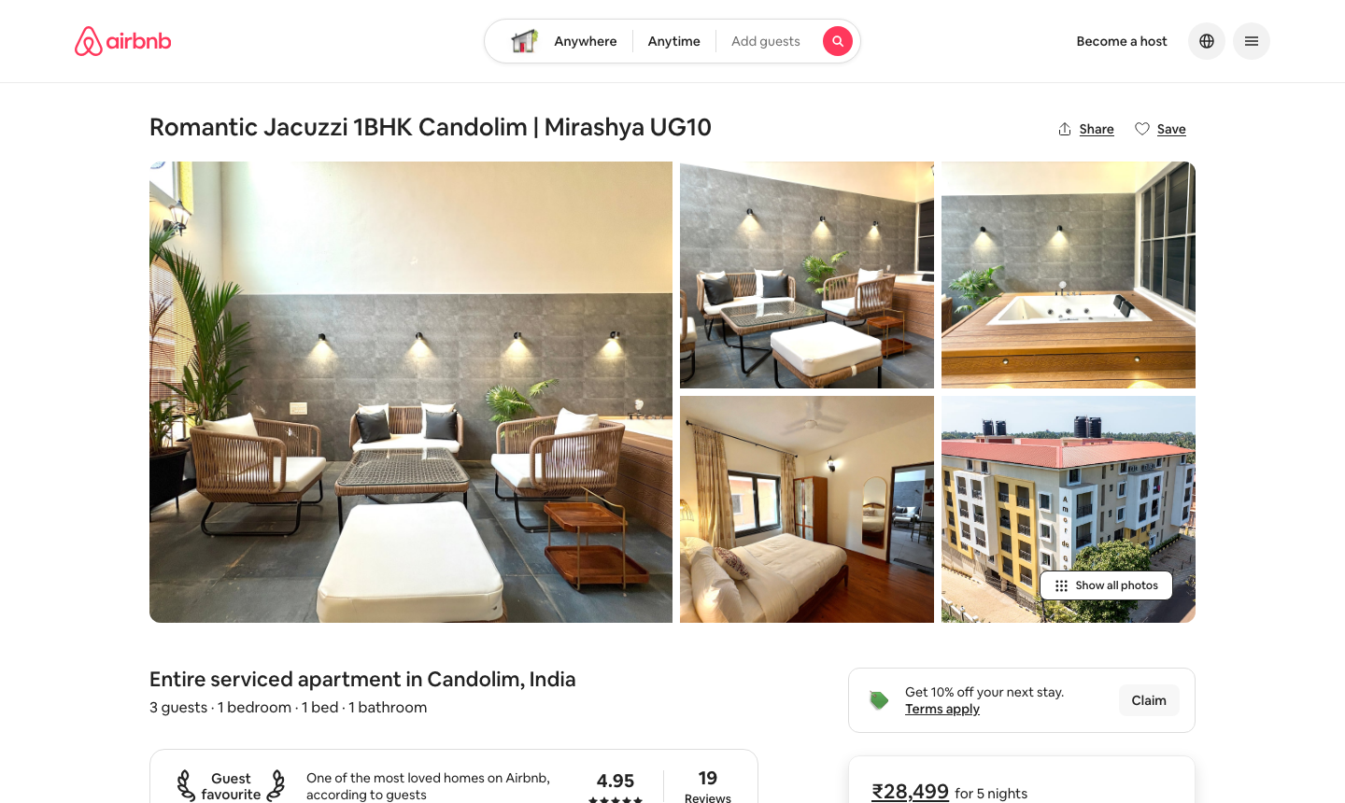
Photo Tour | Full-screen photo gallery opened from Show all photos or any hero image. | 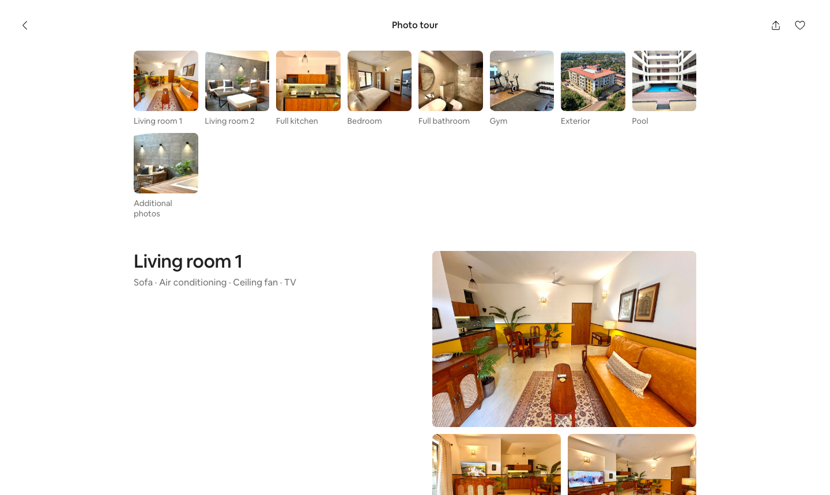
Lightbox | Single-photo viewer opened from any gallery photo with prev/next arrows, keyboard ←/→ navigation. Match the interactions and animations exactly. | 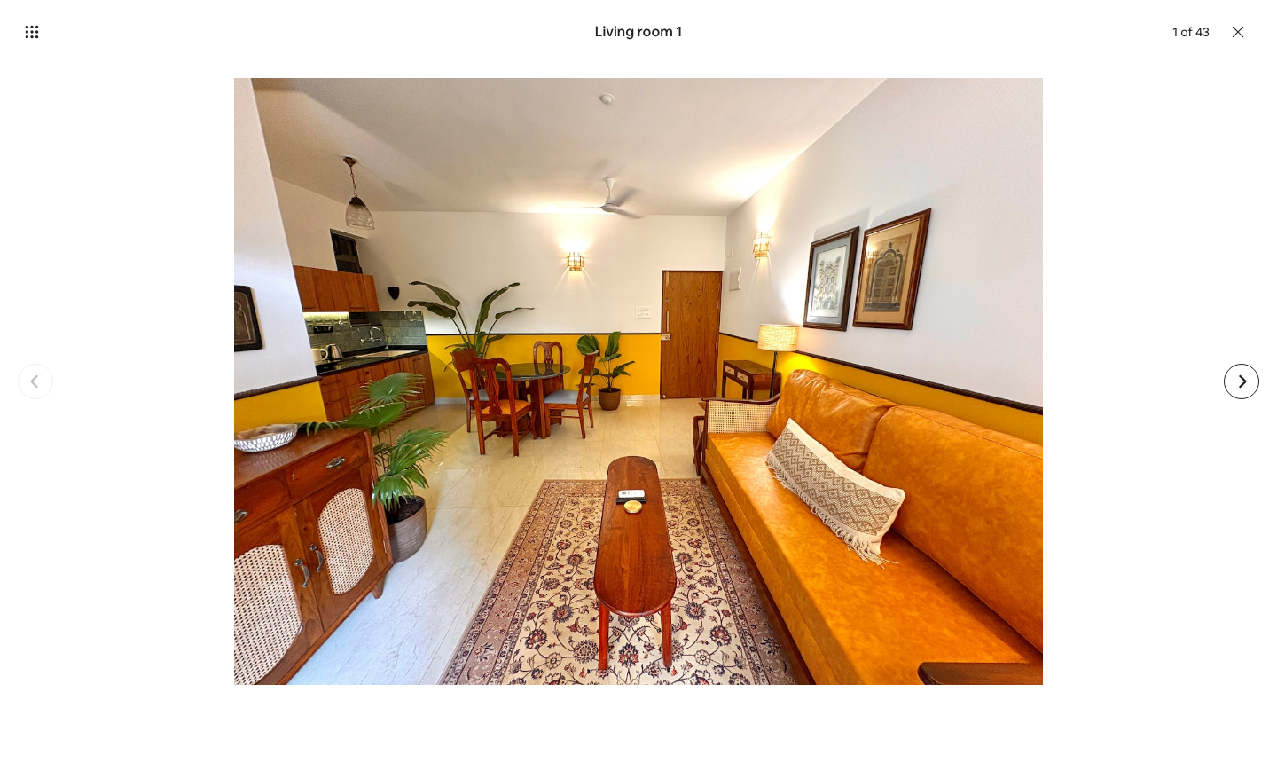
Note: Implement Desktop only; mobile version is not required

Tech Stack

You are free to choose the tech stack you are most comfortable with. Suggested options:

Frontend: React, Next.js, or Angular

Backend: Node.js or Java

Backend is optional. You may also choose to store data in frontend/browser storage if that keeps your implementation simple and focused. You may use Vercel or any other free hosting platform for deployment.

Architecture Diagram

Submit a high-level architecture diagram for a production-scale vacation-rental marketplace (think Airbnb) alongside your app. The diagram should illustrate your scaling strategy for frontend, backend, storage, search, and deployment. Tools like lucid.app or excalidraw are recommended.

What We Will Look At
- Modern AI workflow usage (coding agents, sub-agents, skills, prompts)
- How closely the clone matches the reference, visual fidelity and behavioural parity, including animations, transitions, and accessibility
- Production architecture thinking
- AI subagent configs for code quality and project structure
Please keep the scope focused and do include your sub-agent/skill config files in your submission. A clean, complete implementation is better than an over-engineered incomplete one.

Submission (Important: Please do not push the code to a public GitHub repository.)
Please submit the task as per the instructions shared with you over email. The submission must include the following deliverables:
- A zipped file containing the code and architecture diagram (image/pdf file).
- The sequence of prompts used for AI-assisted development, it might be asked during submission.

